Line and Circle Drawings in Human-Computer Interaction

Lecture Overview
This lecture explores the role of line and circle drawings as fundamental elements in Human-Computer Interaction (HCI). We will examine their use in interface design, sketching algorithms, and user interaction techniques. The session bridges theoretical concepts with practical applications, focusing on how these simple geometric shapes enhance usability and visual communication.

Learning Objectives
By the end of this lecture, students will be able to:
- Understand the significance of line and circle drawings in HCI design.
- Identify key algorithms for rendering lines and circles in digital interfaces.
- Analyze how these shapes contribute to user experience (UX) and interaction efficiency.

Lecture Outline

1. Introduction
- What are Line and Circle Drawings?
  - Basic geometric primitives in computer graphics.
  - Historical context: Early vector displays and pen-based inputs.
- Relevance to HCI
  - Foundation for sketching, diagramming, and interactive tools.
  - Examples: Touchscreen gestures, CAD software, digital whiteboards.

2. Algorithms for Line and Circle Drawings
- Line Drawing Algorithms

  - Digital Differential Analyzer (DDA): Incremental line plotting.
The DDA algorithm is a very simple and efficient algorithm for generating straight lines on a digital display device.
The algorithm starts at one end of the line and calculates the coordinates of each point along the line by adding the incremental changes to the previous point.
In this algorithm, we can perform the calculation in a step by step manner. We use the previous step result in the next step.
As we know the general equation of the straight line is:
y = mx + c
Here, m is the slope of (x1, y1) and (x2, y2).

dx = x2-x1
dy = y2-y1
m = dy/dx
Now, we consider one (start) point (xi, yi) and (xi+1, yi+1) as the next point.
Here i is starting value for x and y coordinator
Then the slope
m = (yi+1 — yi) / (xi+1 — xi)
Now, we have to find the slope between the starting point and ending point.
So, the basic steps of the DDA algorithm are as follows:
Step 1: Calculate the differences in x and y coordinates between the two endpoints: dx = x2 — x1 dy = y2 — y1
Step 2: Determine the number of steps required to draw the line. The number of steps is equal to the larger of |dx| and |dy| since the algorithm needs to iterate over the greater axis.
Step 3: Calculate the increments along the x and y axes: x_increment = dx / steps y_increment = dy / steps
Step 4: Starting from the initial point (x1, y1), successively add the increments (x_increment, y_increment) to reach each subsequent point on the line. Round the coordinates to the nearest integer to ensure they align with the discrete pixels on the digital screen.
Step 5: Repeat Step 4 until you reach the final point (x2, y2).
Example:
Question: Draw a line from P(1,1) to Q(5,9) using DDA algorithm.
Solution:
P(1,1) => x1 = 1, y1= 1
Q(5,9) => x2 = 5, y2 = 9
Now lets calculate the difference:
dx = x2 — x1 = 5 –1 = 4
dy = y2 — y1 = 9 -1 = 8
Now lets calculate total number of points to plot:
noOfPointsToPlot = max(abs(dx), abs(dy)) = max(|4|,|8|) = 8
Now, lets discuss why we go for a max here, because we want to draw line as accurate as possible and accuracy can be given by more no of points.
Now lets calculate increment for both the coordinates.
xInc = dx/noOfPointsToPlot = 4/8 = 0.5
yInc = dy/noOfPointsToPlot = 8/8 = 1
Now, list all the points to be plotted:
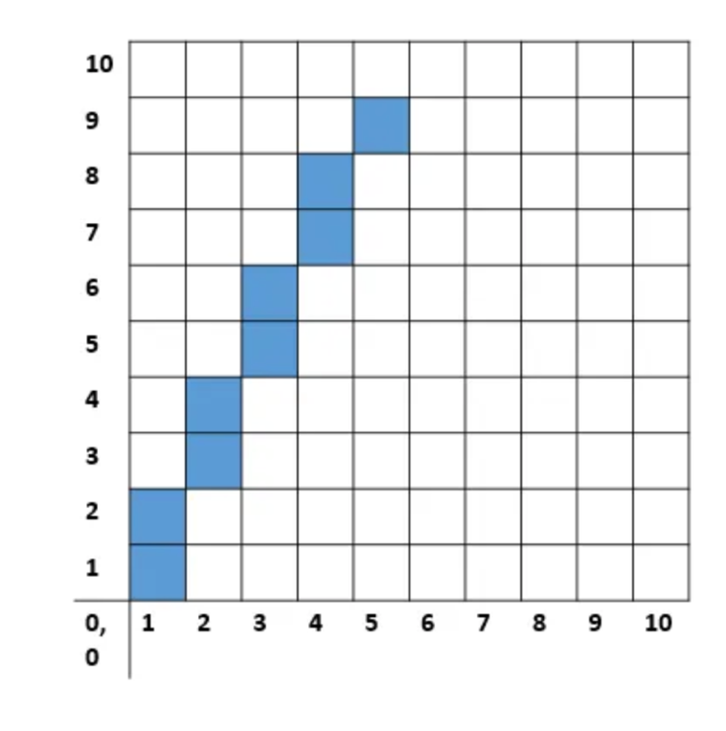

Line drawn from above example is shown in this figure, you can say “How stupid this line is?”. But actually that’s how computer draws the line, if you still don’t agree try drawing a line in paint and zoom it. Currently we are drawing a very small line only 10 pixels, but if you will create bigger line than this discrepancy will not be visible.

Advantages of DDA algorithm
- Simplicity: DDA is a straightforward algorithm with a concise set of steps, making it easy to implement and understand.
- Efficiency: DDA avoids complex mathematical calculations and mainly involves incremental additions, making it computationally efficient for drawing lines.
- Versatility: DDA can draw lines of any slope and length, including vertical and horizontal lines.

Limitations of DDA algorithm
- Round-off Errors: Rounding coordinates to integers during the calculation process can lead to some inaccuracies, causing the line to deviate slightly from its true path. This issue becomes more significant for lines with large slopes.
- Inefficiency for Steep Lines: Since DDA calculates a single pixel at a time, it may not be the most efficient option for steeply sloped lines where many intermediate pixels are skipped.

  - Bresenham’s Line Algorithm: Optimizing integer-based line rendering
Bresenham's Line Algorithm is a way to draw straight lines on a grid (like pixels on a screen) using only whole numbers (integers). It’s super efficient because it avoids messy floating-point math and instead uses simple addition and subtraction to figure out which pixels to light up.
Here’s how it works in simple terms:
Start with two points: You pick a starting point (x1, y1) and an ending point (x2, y2) on the grid.
Decide the path: The algorithm calculates the steepness (slope) of the line but keeps everything in integers by comparing how far it moves horizontally (x) versus vertically (y).
Step-by-step choices: As it moves from the start to the end, it picks the next pixel by checking which option (e.g., go straight or diagonal) keeps the line closest to the ideal path. It uses a "decision variable" (a number it updates with basic math) to make this choice fast.
No fractions: Instead of dealing with decimals (like a slope of 0.7), it scales everything up and tracks errors with integers, so it’s quick and exact for computers.
It’s optimized for rendering lines on screens or printers where you need whole-number coordinates, making it a go-to for old-school graphics and still useful today!

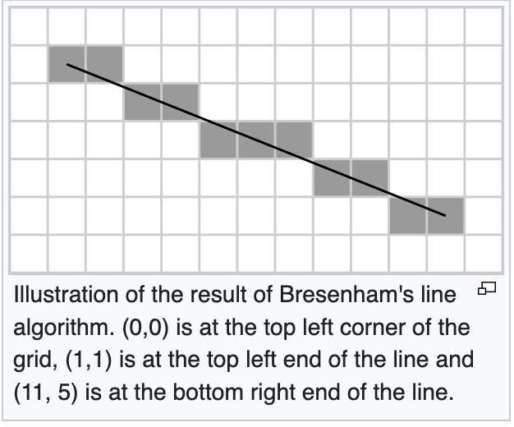
- Circle Drawing Algorithms
  - Midpoint Circle Algorithm: Efficient pixel-based circle generation.
The Midpoint Circle Algorithm (also known as Bresenham’s Circle Algorithm) is a technique used in computer graphics to draw a circle using only integer operations, making it fast and efficient for raster displays.

How It Works:
- A circle is symmetric in 8 directions. So you only need to calculate the points in one eighth (octant) of the circle and reflect them into the other 7.
- You begin at the top of the circle (0, r) and step along the x-axis, choosing between two possible y-values at each step based on a decision parameter.
- The decision parameter determines whether the next pixel goes straight east (E) or southeast (SE).


- Challenges in HCI
  - Anti-aliasing for visual clarity.
In digital graphics, especially when working with screen-based media, we often encounter a visual issue called aliasing—a stair-stepping or jagged effect that appears when curves or diagonal lines are represented on a pixel grid. This can significantly reduce the clarity and quality of visual content.
To address this, we use a technique called anti-aliasing.

🧠 What is Aliasing?
- Aliasing occurs when high-resolution or smooth objects (like curves) are sampled into a lower-resolution format (like screen pixels).
- Since pixels are square, they cannot perfectly represent diagonal or curved lines.
- This results in visible jagged edges, often referred to as "jaggies."
Imagine drawing a circle in MS Paint—it often looks like a set of small staircases rather than a smooth round shape.
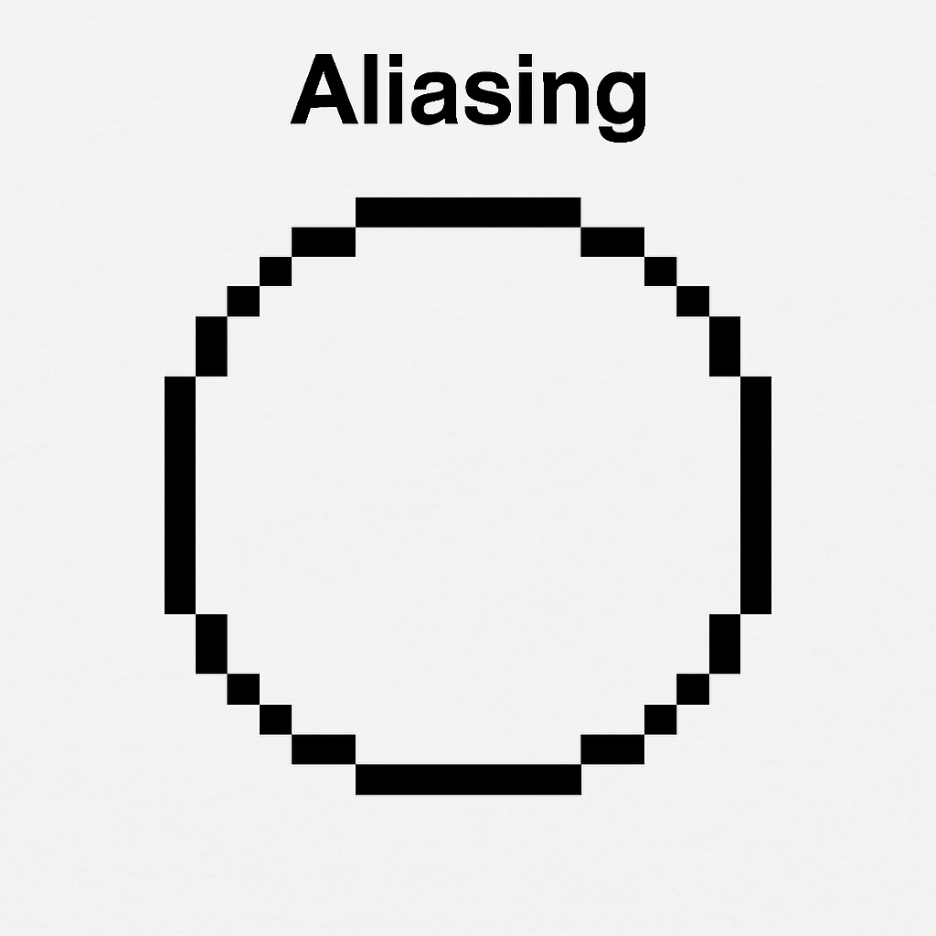

💡 Anti-Aliasing: The Solution
Anti-aliasing is a technique used to smooth out those jagged edges and make digital graphics appear more natural and easier to read.
- It works by blending the edges of objects with background pixels.
- This blending uses varying levels of transparency or intermediate colors to create the illusion of a smoother edge.
Think of anti-aliasing as "fuzzying" the edge slightly so your eye perceives it as smooth rather than blocky.

